Mapping the Obesogenic Environment Workshop

This workbook was prepared by Dr Kim Procter in the Cancer Epidemiology Group, Division of Epidemiology and Biostatistics, LIGHT, University of Leeds.

This workshop provides an overview of a desktop Geographic Information Systems (GIS) software (ArcGIS v.9.0) with the aim of mapping health-related data, including Census data or other survey data. The components of ArcGIS that we will be focusing on today are ArcCatalog, ArcToolBox and ArcMap. You will learn the basics of how to use these items, which you can take away and apply to your own research questions.

ArcGIS is one of the main GIS software packages, created by ESRI. MapInfo is another package used frequently, and the main concepts and techniques introduced today can be applied to MapInfo as well. ArcGIS has more components to the package, while MapInfo is more of a self-contained GIS program. The exact menus and tools will differ between these two programs, but the help menus are very good. Additional support can be found on the websites for each package:

http://www.esri.com/
http://www.mapinfo.com/

PLEASE WORK THROUGH THIS WORK BOOK CHRONOLOGICALLY AND FOLLOW ALL THE INSTRUCTIONS CAREFULLY. Do not skip to subsequent sections (unless directed to do so).

In this workshop we will:
- Map rates of childhood obesity in Leeds and consider how they vary across Leeds
- Map the location of gyms, supermarkets, fast food outlets and parks in Leeds
- Consider access to fast food outlets
- Print your final version of the map(s)

Contents:
Section 1 Data representation
Section 2 Downloading and viewing (ArcCatalog) the files required for this workshop
Section 3 Basics of using ArcMap and ArcToolBox
Section 4 Formatting and printing maps

1. Data representation

Before mapping any data, some basics on data representation need to be covered

Most of the maps you see are choropleth maps, which use a series of colours to represent different categories of data, and fill in each area with the corresponding colour (see Figure 1). This is the method we’ll use here, rather than dot density (where 1 dot = a set number of people or cases) (Figure 2) or graduated symbol (where the relative size of the symbol on the map indicates the number of people or cases in that area) (Figure 3).

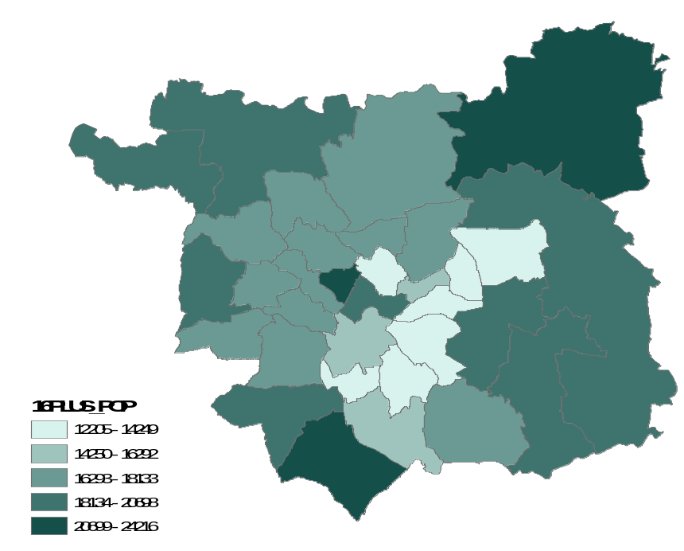

Figure 1. Choropleth map

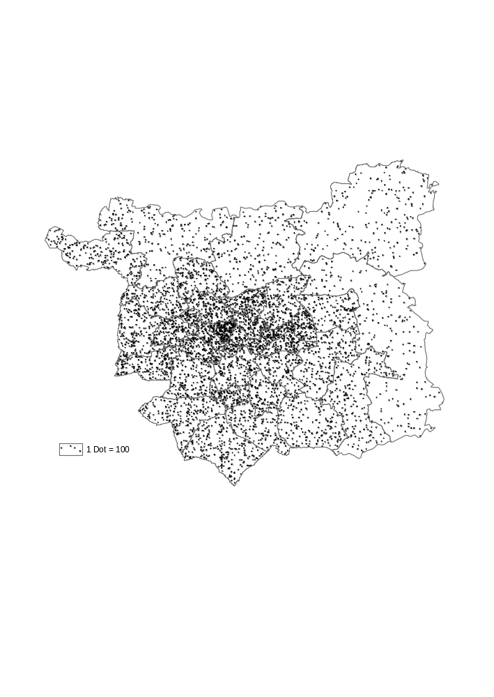
Figure 2. Dot Density map (1 dot = 100 people over the age of 16)

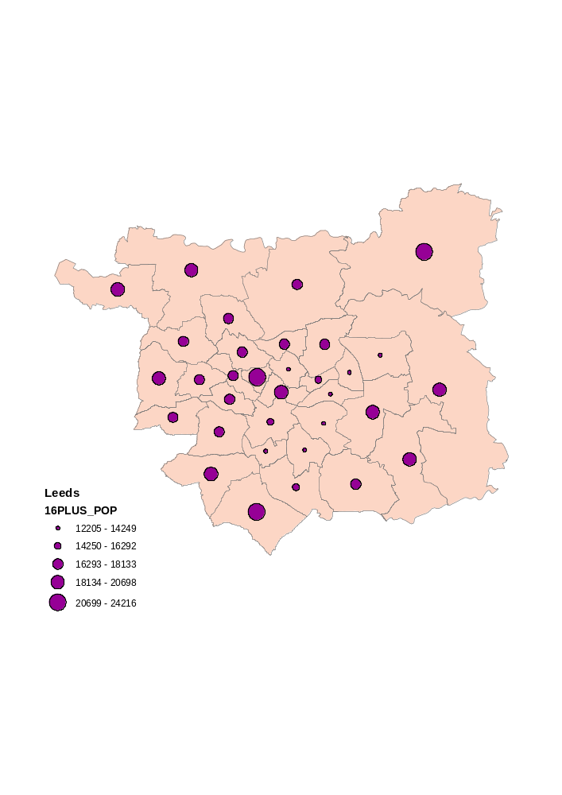
Figure 3. Graduated symbol map

When creating a choropleth map, disease data should not be displayed as absolute numbers. This is because the underlying base population can vary from area to area; using absolute numbers could be misleading. It is normally more meaningful to display the information as a rate, although other formats can also be useful, such as z scores (for example, when considering childhood obesity using a body mass index standard deviation score, BMI SDS).

As an example, consider a hypothetical region with 4 wards. Table 1 summarises the attributes of these wards. If we were to map the absolute number of ill people in these wards, wards A and D would appear to have the most ill people (which they do). However, this would mask the actual problem, which is that nearly half of the population in ward C is ill! If we calculate the rate of the population that is ill and map this instead, it will be clear that the prevalence of illness is lower in ward D than all other areas.

WARD | POPULATION | ILL | % ILL
A | 100 | 25 | 25%
B | 50 | 15 | 30%
C | 25 | 10 | 40%
D | 200 | 20 | 10%

Table 1. Summary of attributes of four hypothetical wards

This example illustrates another common problem with mapping data: small numbers. The size of areal units is important: smaller areas are more homogenous, but then run into small number problems. A common problem with working with relatively small areal units (or small number of population at risk) is the misclassification of risk estimates. The population of ward D is 8 times higher than ward C. When an area has a very low population, a very small change in the absolute number of illness can have a much bigger impact on the rate. The small number problem is essentially a problem of scale, because as the size of the areal units increases, so does the number of cases within the unit (for example, there are more cases of obesity in the UK than at ward level). Gatrell (2002) suggests a number of solutions to the small numbers problem including: aggregating data from a few consecutive years rather than just one year; mapping over a larger geographical scale; and using empirical Bayes estimators. Empirical Bayes estimation method is a ‘smoothing’ approach that gives risk estimates based on mean risks of the area unit and that of neighbouring areas (Leyland & Davies, 2005). In this way it prevents undue attention being focussed on areas with small numbers. Empirical Bayes works by “borrowing strength” from areas where there are large numbers measured to provide a more stable estimate in areas with low numbers measured.

Additionally, Gatrell gives an excellent description of the modifiable areal unit problem, which can cause further trouble when mapping disease data. Briefly, this occurs when the relative location of cases of a disease can be changed depending on the configuration of the areal units. Or in other words, the MAUP occurs when analysing data by area (point data aggregated to areal units) and different results are obtained depending how the areal units are configured; that is, where boundaries are, which is a relatively arbitrary choice i.e. areal units are “modifiable” (Openshaw, 1983). Gatrell uses the example of incidence changing when administrative units (such as wards) or a series of distance bands are placed around a pollution source (Gatrell 2002:53).

In addition to the usual sources of bias that affect individual level data (e.g. selection bias, observation bias, interviewer bias, recall bias) there is the problem of “ecological fallacy” with aggregated areal data. This is the failure of the expected ecologic effect (i.e. at population or community level) estimates to reflect the biologic effect at the individual level (Rothman & Greenland, 1998) and is due to heterogeneity within areal units.

As the spatial scale of the data reduces, by using a finer geography for analysis, researchers can run into confidentiality problems. Accordingly data must be anonymised and sensitivity is required over maps published to ensure children cannot be identified.

When working with your own data, please take some time to consider whether any data you wish to map can be influenced by one of these geographical problems.
- Downloading and viewing the data files

  - Downloading the files

For this workshop, we’ve created (fictional) datasets of obesity, fast food outlets, gyms, parks and supermarkets to build up our obesogenic environment.

The first thing we need to do is access some data that we’ll use in the mapping exercise (see board/tutor for details of location). Save all of this data in the same folder (the workbook assumes you have called this folder “Workshop_files”).

Note for students – please download all the files not just the six listed below (reasons explained in next section).
Note for tutor - files required for this workshop:
Gym.xls Parks.shp
FastFood.xls Leeds_caswards.shp
Supermarket.xls Obese.dbf

  - Viewing the data in ArcCatalog

First of all open up windows explorer and look at your files. It will look something like this:

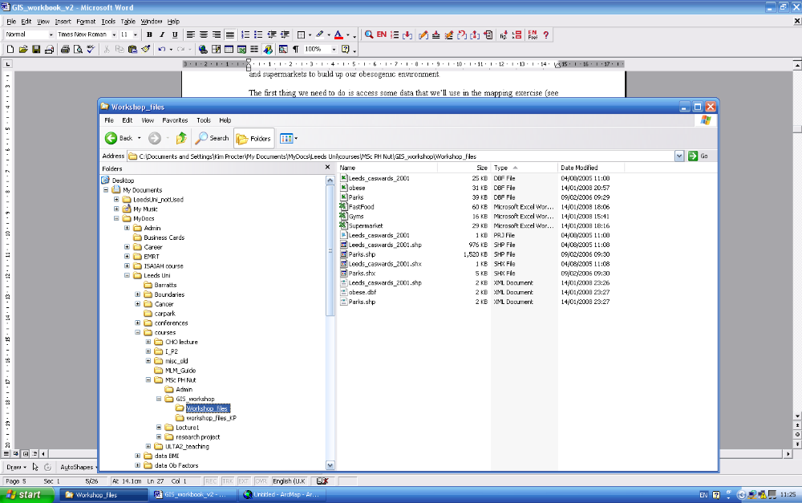

You will see that there are many different file types included in this folder: .shp, .shx, .prj, .xml, .dbf, etc. Each of these is necessary for ArcGIS to correctly project and display the data in the appropriate format.

Notice that the “obese” file is in database IV format (i.e. Obese.dbf). ArcMap can read this type of data but not excel files.

Now open up ArcCatalog and look at your files:

To open ArcCatalog: Start→ Programs → ArcGIS 9.1→ArcGIS → ArcCatalog

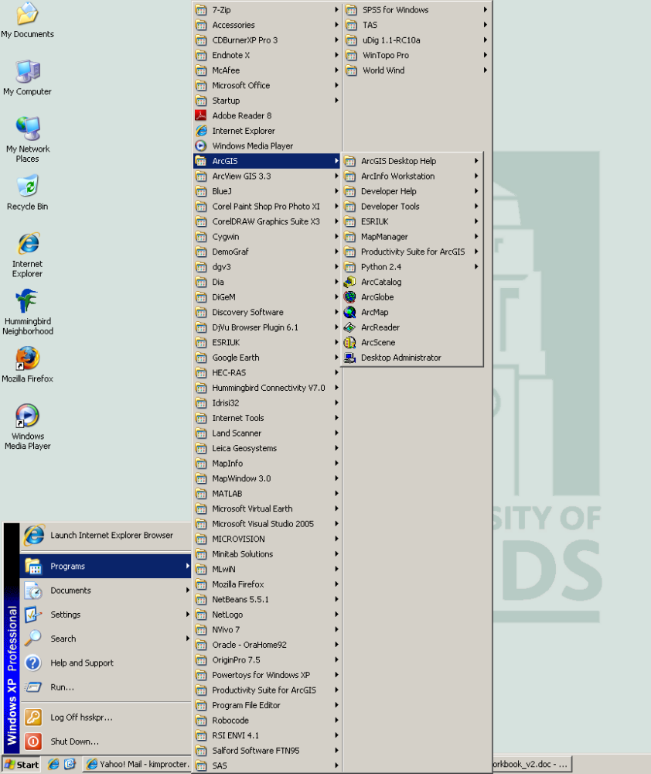

Using the file tree in the left hand frame of ArcCatalog, navigate to C:\Documents and Settings\userid\Desktop\Workshop_files (i.e. where ever you just saved the workshop files to).

Troubleshoot - If you cannot see the Desktop (i.e. your directory where you saved your files), you will need to add it to ArcCatalog. To do this: Select File → Connect folder and choose the directory where you saved your files.

Once you have navigated to your folder with the workshop files, you should see something like this:

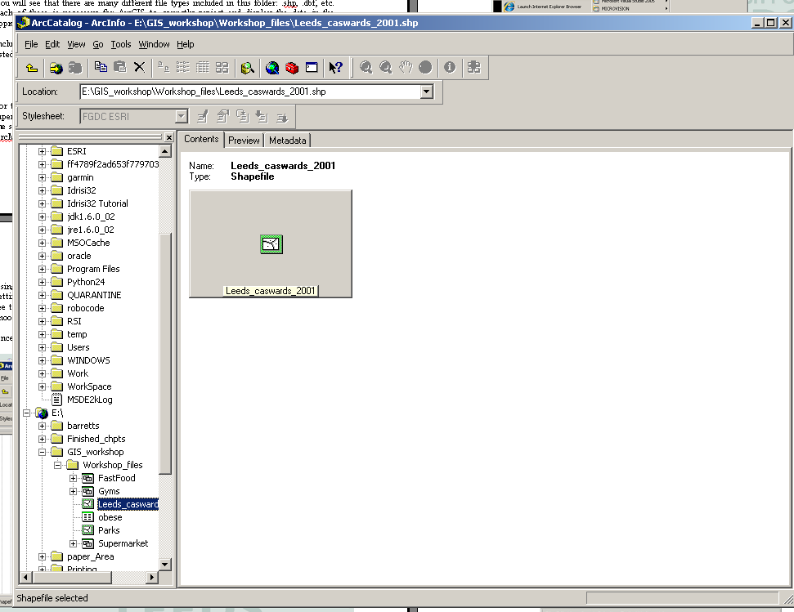

ArcCatalog allows you to view and organise the geographical datasets quickly, similar to Windows Explorer. However, you’ll notice that there appear to be far fewer files than when you looked in windows explorer. This is because ArcCatalog effectively combines all the different files required to project a map into one file (which is what you see). Accordingly it is important that you do NOT manage your ArcGIS files using windows explorer, rather you must use ArcCatalog. Any changes you do in windows explorer will only operate on that specific file. Whereas if you do changes in ArcCatalog, it will automatically ensure that all the files are managed simultaneously.

If you click on the Contents tab in the right hand side window, each of the files is shown with an icon to indicate what type of data is included in the folder.
- Point data represents a point on the map, such as a house or store location (e.g. a gym)
- Lines represent data like road networks (e.g. Roads)
- Polygons represent areas, often Census or administrative boundaries (e.g. Leeds ward boundaries)

You can use the Preview tab to see what the data will look like on a map, and the Metadata tab provides you with information about the data included in each dataset.
- Basics in ArcMap and ArcToolBox

  - Adding data in ArcMap

In this section, you’ll learn how to add data to ArcMap (ready for mapping)

On the ArcCatalog menu bar, there are icons for ArcMap and ArcToolBox Click on the icon for ArcMap to open this application.

When ArcMap opens, you’ll see a default window:

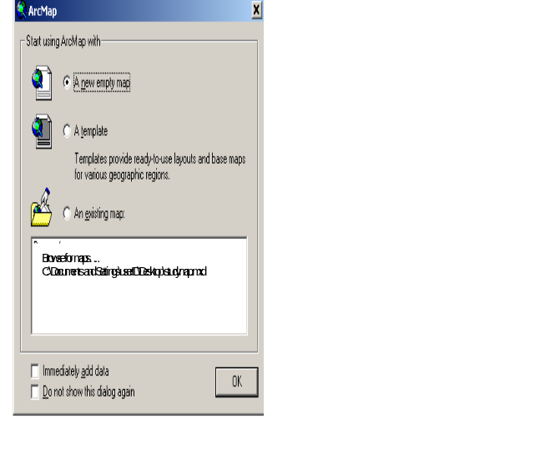

In this window, the default option is ‘A new empty map’. This is what we want, so click OK and a new window opens.

The set of frames that open hold your ArcMap workspace, with the map view on the right (B) and the data layers on the left (A).

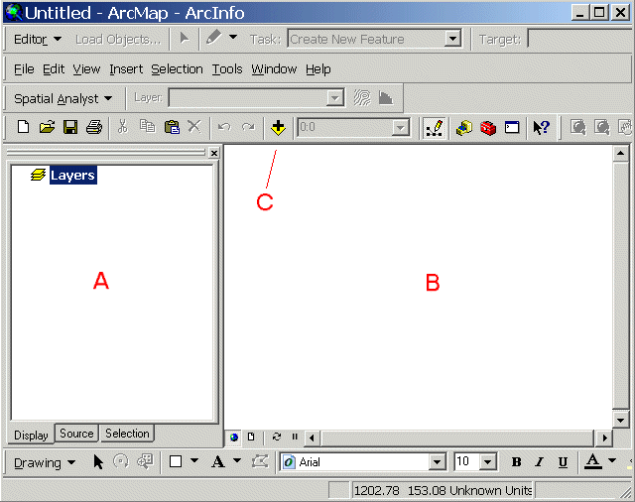
The next step is to add our data to the view.
- Click on the ‘Add Data’ icon (the + symbol, indicated by C above)
- Select the Leeds_caswards_2001.shp file from the window (you may need to navigate to the correct folder again: C:/Desktop/Obesity – or wherever you saved it)
- Click ‘Add’. You should see the map appear in the right hand window, and the file name appear in the left hand window under ‘Layers’.

This shapefile was downloaded from UK Borders (http://edina.ac.uk/ukborders/). A boundary layer is required for any map – either like this, any scale can be used (see UK Borders website for more information), or perhaps using a digimap background (e.g. like an A-Z), etc.

If you want to change the colour of the map:
- Right-click on the file name
- Choose ‘Properties’.
- Select the Symbology tab
- Double-click the square of colour under ‘Symbol’.
- The next window allows you to change the colour of the polygons and the outline colours too, which is useful when you have multiple datasets (layers) projected simultaneously.

A shortcut option is to double-click the square of colour next to the data layer. This opens a symbol selector window where you can also change the colour of the polygon fill and the outline colour as well. The same applies to datasets that are points or lines, either double-click the symbol to select a new appearance or right-click the file name and choose ‘Properties’ then Symbology.

Please note, if you untick the check box to the left of the file name, “Leeds_caswards_2001”, in the left hand panel, the map will disappear from the view. Keep this in mind when you have several layers of data loaded together. The data layers will appear on the map in the same order as shown in the data layers window. If you want to move one layer in front of another, click the Display tab in the data layers window and click and drag the layer you want in front to the top of the list.

  - Summarizing data in ArcMap

In this section, you’ll learn how to summarise data by a particular variable, such as the geographic unit used

Add the obesity data to the workspace. To do this, as before with adding the shapefiles:
- Click on the ‘Add Data’ icon (the + symbol)
- Navigate to the C:/Desktop/Obesity/Obese.dbf.
- Double click the Obese.dbf file to add this dataset to the workspace

Once added, open the file (right click, then choose ‘Open’) and have a look at the data. Notice that the table has a column “Zone Code” and a few other columns of information about each child, such as age, BMI and BMI SDS (this is fictitious data!!).

(This workshop is not going to explain how the BMI SDS figure is calculated. For your reference, it uses the British reference dataset, with obesity defined as above the 98th centile, and overweight as above the 91st centile).

As we want to consider the data by ward, not individually, it is necessary to summarize the obesity dataset by ward. To access the “Summarize” function:
- Open the file that you want to summarize – in this case the obese file.
- Scroll to the right to see all the columns.
- Left click over the column heading “ZONE_CODE”, which should highlight the whole column.
- Then right click and choose the third option: Summarize.

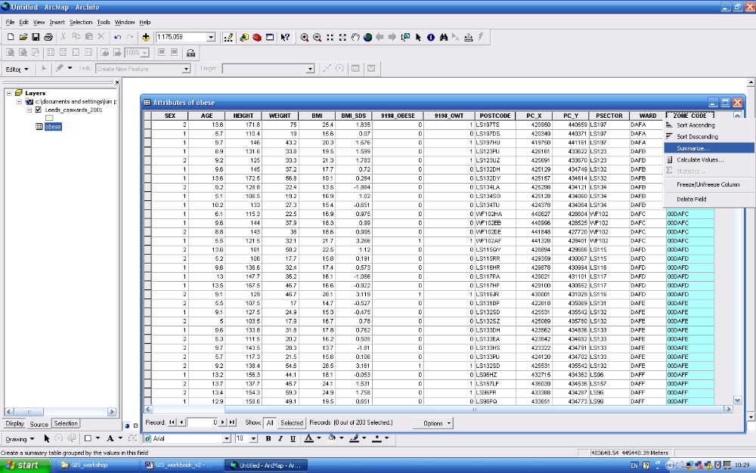

- This brings up a new window called “Summarize”, with three sections to be completed.

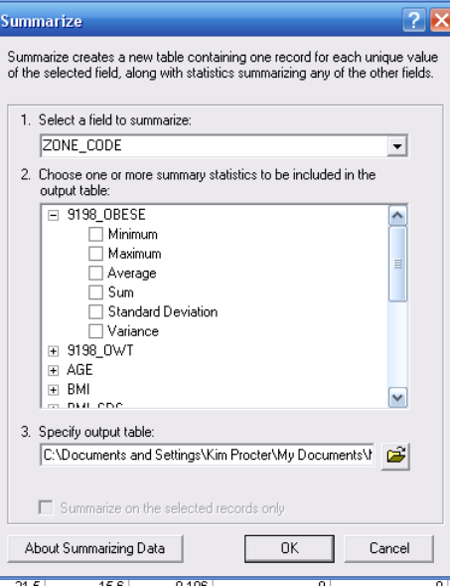

- 1. Select a field to minimize – this will already be completed with “Zone_Code” (if it says any thing else you’ve highlighted the wrong column).

- 2. Choose one or more summary statistics to be included in the output table – here, you need to choose which variables you want to summarize. You ‘choose’ a variable by ticking the box to the left of the variable (e.g. “minimum”). To expand the choice of variables click on the + sign to the right of the variable (e.g. “9198_OWT”).

For example, you may want to calculate the average age of children measure in each ward, the number of obese and/or overweight children, the mean and standard deviation of the BMI SDS, etc. Please choose whatever variables you feel are important (which must include the number of obese children – think carefully about which box you need to tick to get it calculated for you). Note, the calculation will automatically return the number of children measured in each ward (i.e. the number of records summarized for each ward).

- 3. Specify output table – click on “browse” (the yellow folder button) to save the file in the same folder as your other GIS files (do NOT save it in a ‘temp’ file – this will cause you map to crash later in the workshop). Call the file something logical – we have used “Obese_sum”.

- Click ok. It will ask if you want to add the new table to the map – click yes.

This has just creating a new table that summarises the unique values contained in one field from the existing table, as well as statistics for the other fields. For example, for each ward you could summarise the number of obese children and their mean age.

Open the new table and check it has the data you expect (in case of errors). It should look something like this (depending what variables you asked to be summarized):

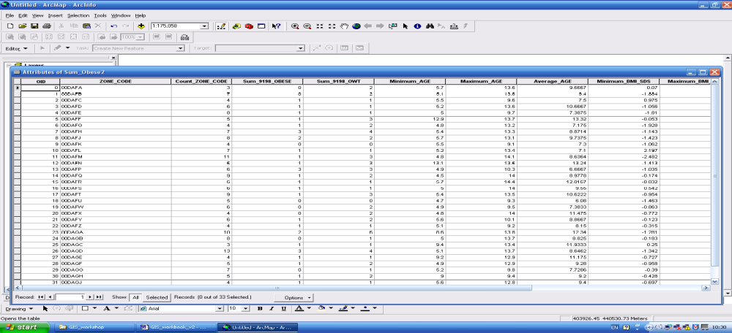

You may be interested to see which ward has the highest or lowest obese population. If you right-click on the obese column name (“Sum_9198_Obese” in our example – you may have changed your column names) in the table and select ‘Sort Ascending’ the table will automatically be sorted from lowest to highest number of obese children in each ward:

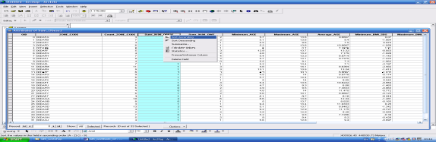

If you choose ‘Statistics’ from the drop-down menu, ArcMap will return a table of statistics for that column.

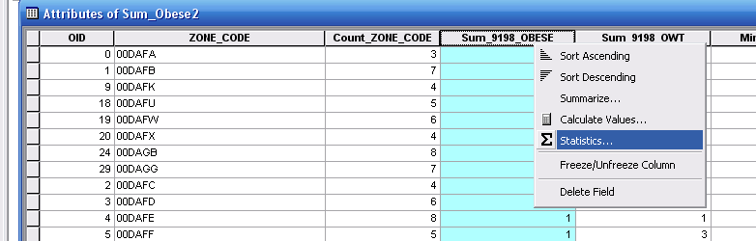

Which will look something like this:

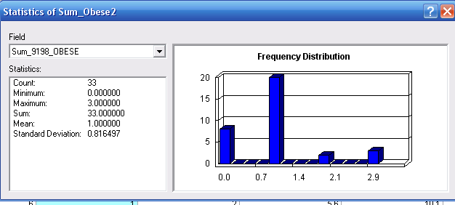

Write down here what your graph tells you:
The x axis variable is:_________________________________________________________
The y axis variable is:_________________________________________________________
There are 33 [what?]_________________________________________________________

Explain the range, mean, and standard deviation results:_____________________________
___________________________________________________________________________
___________________________________________________________________________

  - Calculations in ArcMap

This section explains some of the options for how to do calculations in ArcMap

If we want to map the rates of obesity across Leeds, it is firstly necessary to calculate the rates for each ward. We can do all this by using ArcToolBox.

(An alternative of course is to do this calculations in a file in excel, to save the new file as a .dbf, and to ‘add’ the new file to the map. There are also other ways to do it in ArcMap – see help for more details).
Click on the ArcToolBox icon to open the ArcToolBox frame in the workspace. Click on Data Management Tools →Fields → Add field, and this will open a window that allows you to add a new column to an existing table.
(Alternatively you can open the sum_obese file, click on Options, and choose “Add field”).

Below is an example of how you should fill in the options. You may have to choose the Leeds layer by navigating to its location in the hard drive using the folder icon (circled below in red). Note, we have called the new column “ObeseRate” and we have set the field type to ‘double’, which allows for decimal places. Use the integer options if you do not need to include decimal places (short or long depending on the length of the numbers).

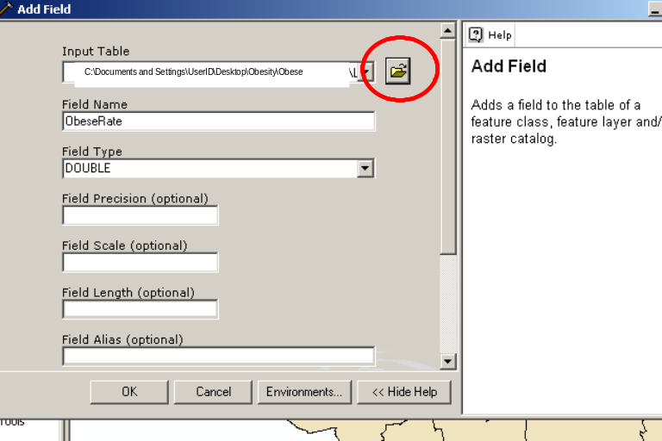

When you click OK, you may need to close and re-open the attribute table to see the new column.

Navigate back to the ArcToolBox frame, then double-click the ‘Calculate Field’ option.

(Alternatively it is possible to simply highlight the column and click on “Calculate Values”, but it is not possible to edit these changes once done).

This brings up the Calculate Field window and you use this window to calculate the rate of obese children in each ward:
- Input Table - as before you many need to navigate to the correct input table (i.e. SumObese) by clicking on the folder button to the right of the Input Table box.
- The Field Name relates to the relevant file and name of the column to hold the calculated values (i.e. ObeseRate).
- The Expression box is where the calculation is input. So to calculate the percentage of obese children we need to type in the expression Sum_9198Obese / Count_Zone (i.e. the number of obese children in each ward / the number of children measured). Do this by clicking on the button (picture of a calculator) to the left of the Expression box and choosing the relevant columns.
- When you click OK, it will update the column in the attribute table.

You may need to refresh the table (i.e. close and re-open it).
Open the table and check that the new column, with the calculations, is there.
Close the ArcToolBox frame.

  - Joining data in ArcMap

In this section, you’ll learn how to join data from your own studies to an existing dataset/boundary file

The current map shows the locations and shapes of the Census Area Statistic (CAS) wards for Leeds. This shapefile comes with a small set of data (attributes) about each ward.

To view this data:
- Right-click on the file name
- Choose ‘Open Attribute Table’. This opens a window with a table in it holding the attributes, or data, associated with the shapefile.
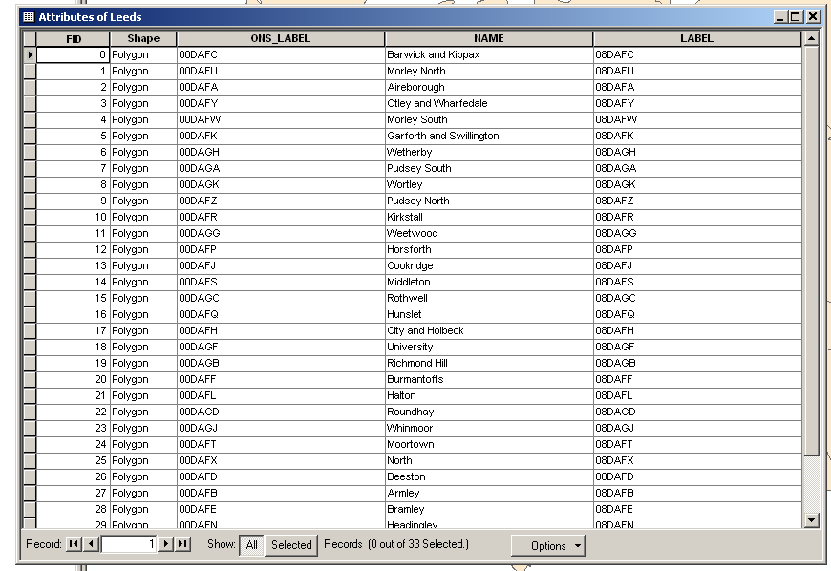

As you can see, only a minimal amount of data comes with the boundary files. If you have data you wish to map, you need to join that dataset to the boundary shapefile.

The key to joining data in ArcMap is to ensure you have one column of data in common between the two datasets. In this case, ONS_LABEL in the Leeds attribute table and ZONE_CODE in the obesity tables match, so we’ll base the join between the shapefile and dataset on these columns.

To add attributes to the map, it is necessary to join the obesity data to the existing Leeds map. If you were to try to join the ward boundary file (Leeds_caswards) to the obesity file (obese.dbf), this would simply takes the first individual for each ward and would not correctly summarise the individual obesity data by ward. Accordingly it was necessary to summarise the obesity file by ward, before joining it to the boundary (ward) file – as described above. Accordingly we will join the sum_obese table to the Leeds ward boundary file.

Now you are ready to join the obesity data (summarised by ward) to the ward boundary data:
- Start by right-clicking the Leeds layer name in the left frame (i.e. Leeds_caswards)
- Select Joins and Relates, then select Join:

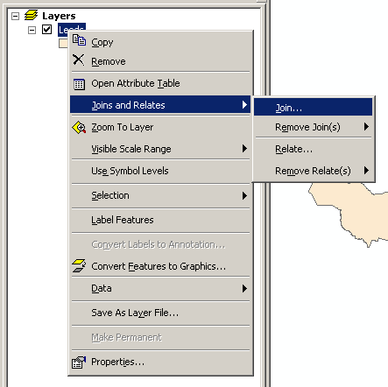

- This will open the Join window, which you want to fill like this, then click “OK”:

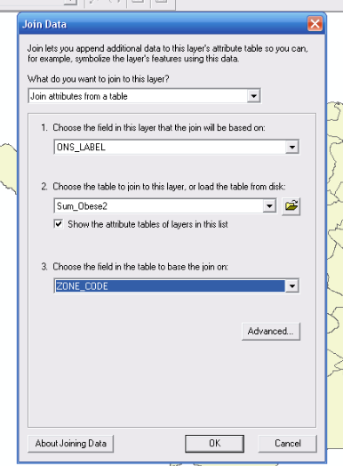

- You will get a pop-up that offers to index the join. Click “Yes” for this and the join will be complete.

Open the attribute table for the Leeds layer again, scroll to the right, and you’ll see that some new columns have been added. The join was successful.

  - Mapping data

The next section shows you how to map the data

Returning to the example, to map the data:
- Right-click the layer name (Leeds_caswards) in the left frame
- Select ‘Properties’
- Choose the Symbology tab again
- This time look in the left hand frame and select Quantities→ Graduated colors
- Fill in the window, specifying the column of data you’re mapping (in the ‘Value’ box) and which colour ramp to use (as shown below).
- Ignore the Normalization box. This data is already normalised by number of children measured.

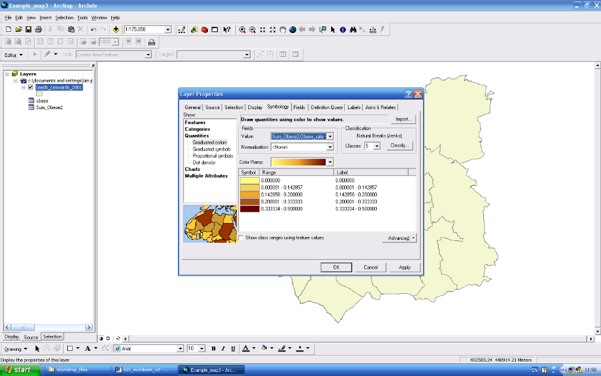

- Click on apply, and the map will update to reflect your choices. So you should now see a shaded in map. Depending on the colour scheme you picked, most likely the darker shades will indicate a higher percentage of the population in that ward are obese.

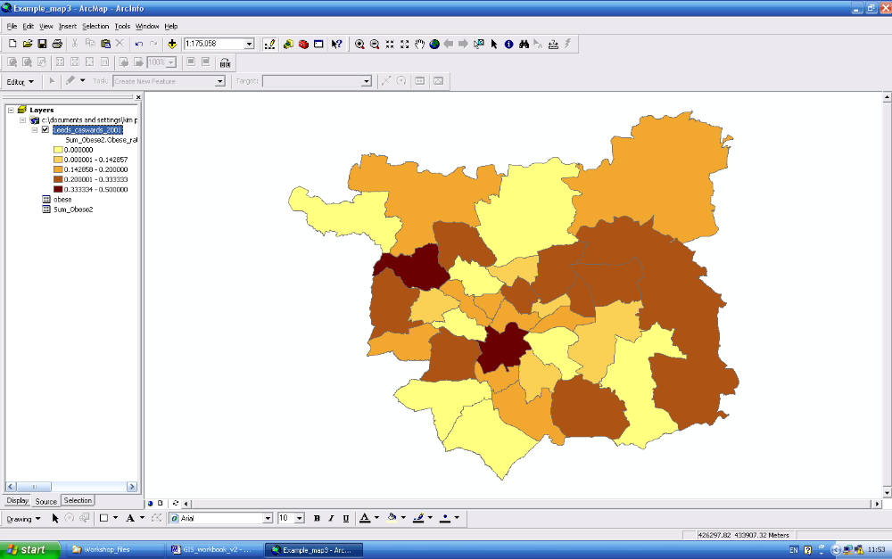

Now go back into the Symbology tab (click layer name, select “Properties”, choose symbology, choose “Quantities” and “Graduated colors”. Do the following:

- Try different classification schemes
The default classification scheme for choropleth maps is Natural Breaks. Depending on your dataset, you may need to adjust the classification. To change it, click on ‘Classify’ and the window will provide the other options for classification. The other options include manual, quintile, equal break, etc. Have a quick try with the other options to see how they affect your map.
- Change the number of classes to 2, 3, 6, and see how this affects your map.
- Change the number of decimal places in “Label” to just one.
To change the number of decimal places in the labels, click on the grey bar and select “format labels”. You can also type directly over the label.
- Choose a different colour scheme to the default one.

Make notes here about how this affects your map and the reason for the final versions you decide to go with:
____________________________________________________________________________________________________________________________________________________________________________________________________________________________________________________________________________________________________________

Now we can map and display the rates of childhood obesity by ward.

Your final (submitted) map should include a text box detailing what classification system you have used, and the labels/legends should only be to one decimal place.

  - Identifying locations on the map and adding buffers

This section explains how to identify locations on the map

A useful tool in ArcMap is the ‘Identify’ tool, indicated by 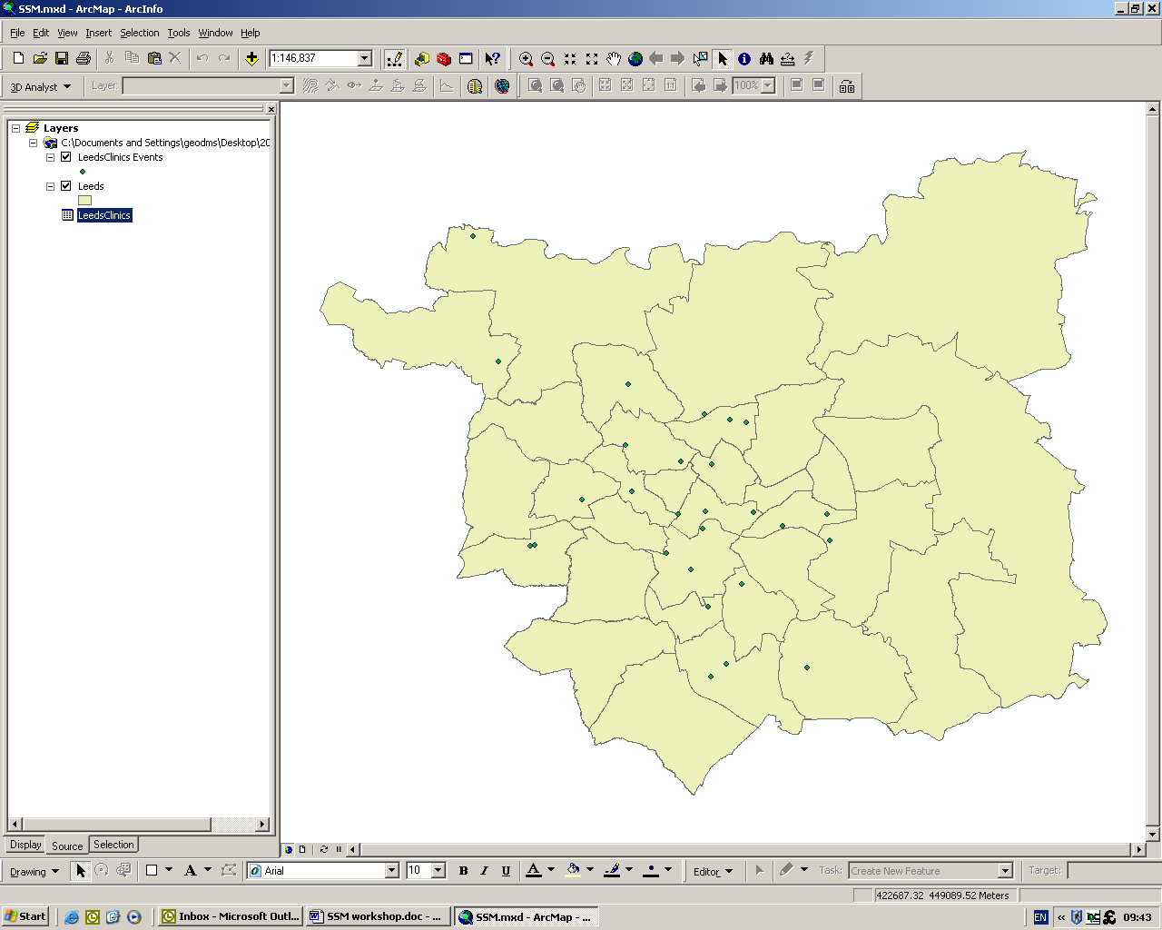 on the toolbar. Click on this icon (notice that the cursor for your mouse changes slightly to indicate that you are using the identify tool) and then click on one of the points or polygons on the map, a table will pop up with the associated attribute information for that object.

If you want to label all of the features of a layer, right-click the layer name and select ‘Label Features’. ArcMap will choose default labels and font, but these can be changed in Properties under the Labels tab.

Experiment with this feature and add relevant labels to your map.

  - Adding point data

This section shows how to add point data (e.g. locations of gyms) to the map

**If there is less than 20 minutes left in the workshop,
you may want to skip ahead to section 4**

Add the gyms file to the map in the same way as the Obese file was added. Hint – first you will have to convert the .xls file to a .dbf file:
- Choose ‘File→ Save As’
- Scroll down to select “DBF 4 (Dbase IV)” (.dbf) from the options.
- Check your .dbf file to make sure that after conversion all of the data is visible in each column, and also that you have not lost any decimal places with your data. If you have, the following troubleshooting suggestions may help: if part of the name or a number is obscured because the column isn’t wide enough in the .xls file, it will be truncated when saved as a .dbf; also, it sometimes helps to format the excel file, e.g. to 2 decimal places, then resave as a .dbf).

Click on the add data icon as before and select ‘Gyms.dbf’ from the data folder. At the bottom of the left hand frame, check that you are in the Source tab, otherwise you won’t be able to see the data file. Open the attribute table and have a look at the data file. The location of each gym is given by a postcode and a set of x and y coordinates. We can use these to project point data onto a map.

Right-click on the file name for Gyms and select ‘Display XY data…’.

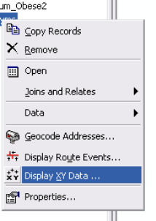

A window will open where you can specify the columns (fields) that contain the X and Y coordinates for each location (namely, X Field and Y Field). Scroll to select these column names, if necessary.

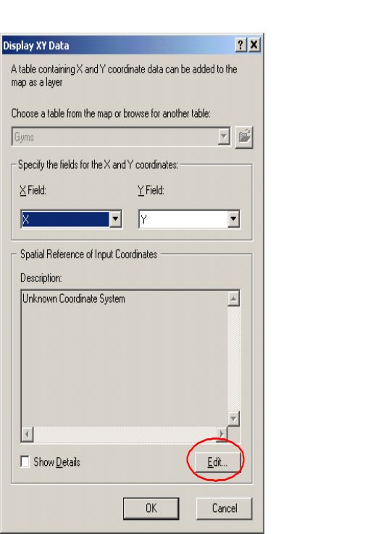

Under ‘Description’ you will see that the data does not have a coordinate system specified (‘Unknown coordinate system’), so one will need to be selected. In the same window, click on the ‘Edit’ button (circled above) to open a new window that provides options for coordinate systems:

In the next window (‘Spatial Reference Properties’):
- click the Select button
- choose Projected Coordinate Systems
- choose National Grids
- click on ‘British National Grid.prj’
- Click Add
- Click Apply, OK and OK

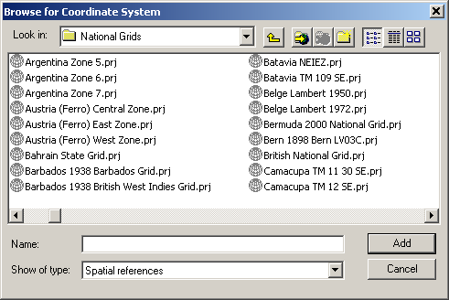

ArcMap will add the layer on the map as ‘Gyms Events’ and it will automatically be visible (remember, the square box to the left of the file name needs to be ticked in order to see the points on the map).

You should now see something like this (colours will vary):

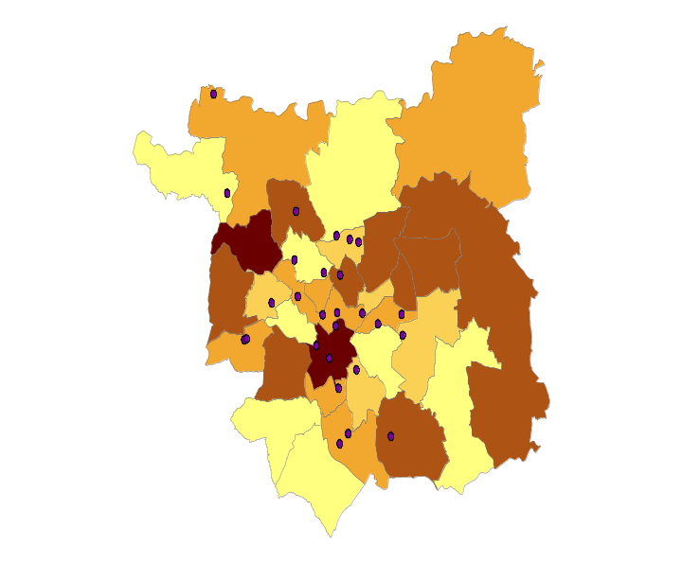

Now add the other relevant layers: i.e. Fast Food, Parks, Supermarkets.

Hint – you will have to convert the fast food and supermarkets files from excel to dbf before you can add it to your map. Also the Fast food and supermarket files will need projecting as point data (using the “display XY data” command).

Experiment with the legend options (see section 4 for more details on how to do this) so that each attribute is displayed differently and clearly. This will then show a more complete profile of some of the food and physical activity options in Leeds.

You may want to include one of these maps as your final submission (i.e. submit a separate buffer map in addition to this map).

  - Adding buffers

In this section, how to add a ‘buffer’ to your data in the map is explained

**If there is less than 20 minutes left in the workshop,
you may want to skip ahead to section 1.4**

If we want to see how much access there is to fast food, you can look at this by using a buffer.

Buffers can be created around data layers (in our example, FastFood)

Open your ArcToolBox and choose Analysis Tools, then Proximity, then Buffer.

A new window is opened:

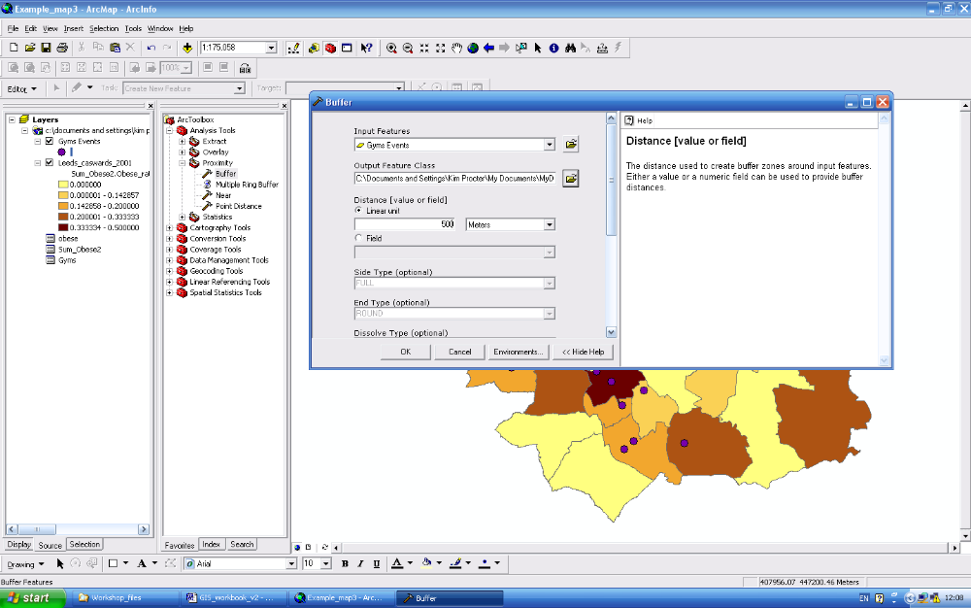

Input features – the name of the layer file that contains the data you want to put the buffer round (click on the drop down arrow to get a menu of potential files), e.g. supermarket, gym, fast food outlets.

Output feature class – the name and location of the output file from this analysis (make sure it is the same folder as your other GIS files).

Here, you can specify the distance to buffer around each object. Try 500 meters to begin.

Then click OK.

You should see a new shapefile appear, and the map will look something like this (colours will differ). It has put a buffer of the specified distance around each fast food outlet.

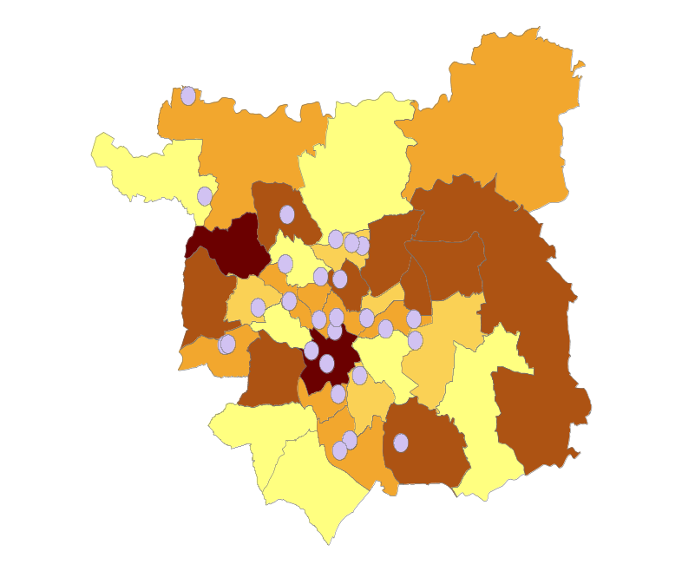

[Your fast food outlet map will look slightly different to the one above]
Work out how to dissolve the buffer boundaries into one (hint - the help function may be useful):

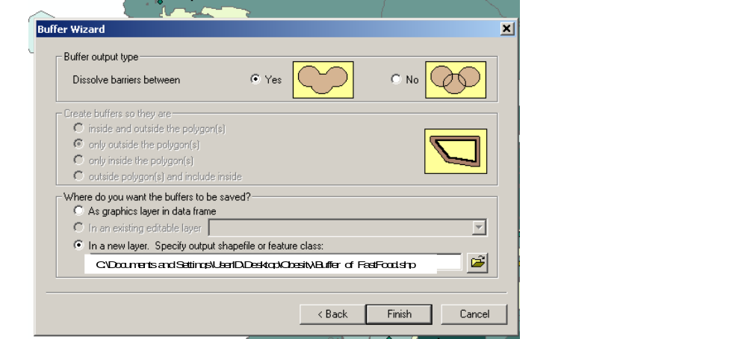

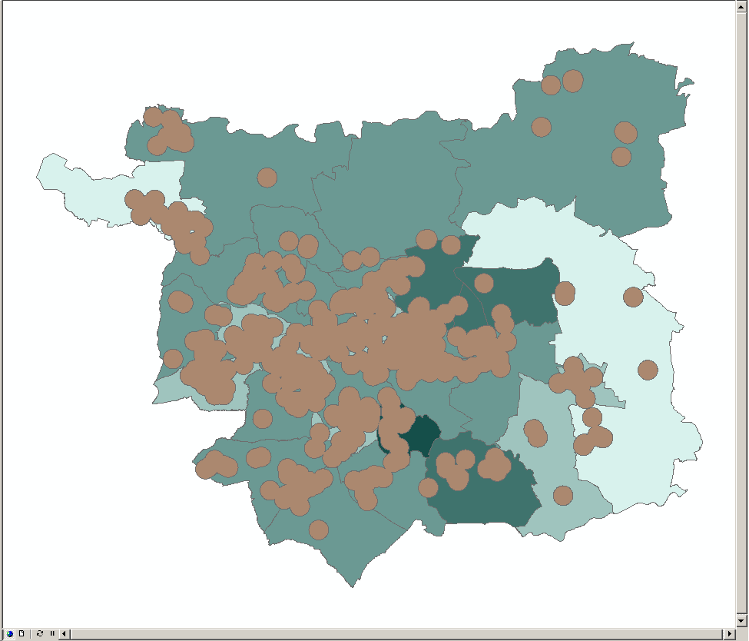

So now we can map our obesity data and put buffer zones around the other features (e.g. fast food outlets, parks, gyms, supermarkets).
  - Use of Overlay and Intersect functions

This section explains how to calculate populations in buffer zones

**If there is less than 20 minutes left in the workshop,
you may want to skip ahead to section 4**

The next step in this example is to calculate how many obese children live in easy access to the fast food outlets (note, this analysis ignores the small number problems inherent in this example dataset). In doing this we are assuming that ‘easy access’ means the obese child lives within 500m of an outlet (as per our buffer zone). Please note, this is a simplistic assumption and there are many alternative ways of defining ‘easy access’ – if using this to analyse your own data we would suggest you consider what definition you use very carefully.

**See NB at end of this section. We will NOT get an accurate count of ONLY the population living in the buffered areas, rather an estimate based on the population of each ward within the buffers. For your own analysis, it would be better to use smaller areal units like output areas (OAs). For this workshop, we wanted you to be aware of the intersect procedure so you can use this process on suitable datasets.**

To calculate the percent of the obese population served by the clinics, go to ArcToolBox and select Analysis Tools → Overlay → Intersect.

This brings up the following window. This command will intersect the dissolved buffer shapefile with the base layer that has the population information. From the drop down menu, choose the layers to intersect (the Leeds population layer and the buffer layer) in the Input Features box. Note, the Output Feature Class box automatically assigns a folder and file name for the output file. If you go into this box the filename can be changed (which is normally recommended, but no need to do that in today’s workshop).

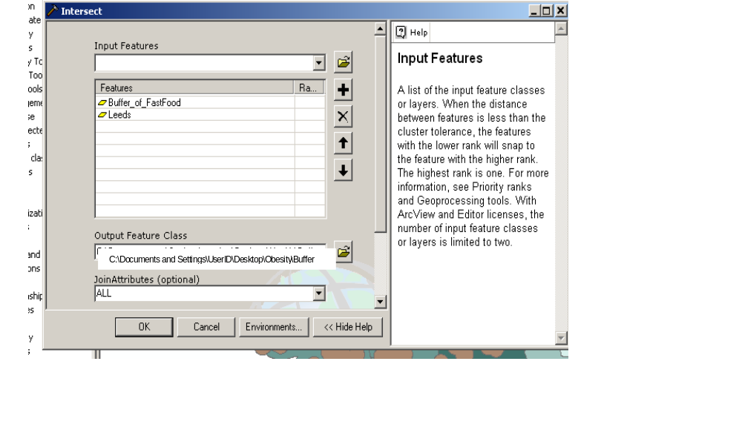

Then for the Features box, select both the population file (Leeds) and the buffer file (Buffer_of_FastFood). This will intersect the two files and merge the attributes into one layer with the resulting map looking similar to this:

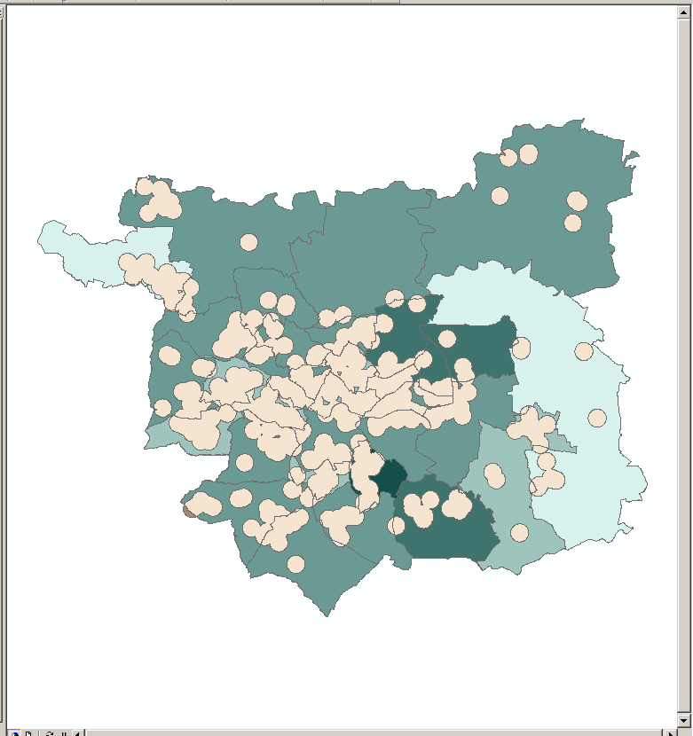

To find out how many obese people are served by the outlets (assuming the 500m buffer):
- Right-click on the newly created intersect file (Buffer_of_FastFood_Intersect.shp)
- Open the attribute table.
- Find the population column (using number of children measured – a larger analysis might use actual ward population figures, this data can be downloaded from the Census website, CasWeb)
- Right-click on it and choose Statistics. This will tell you the total number of children measured (by ward) touched by the 1.0 mile buffer.

**NB: ArcMap counts the number of children measured/population for the entire ward if any part of it falls within the buffer, so the population sum that will come out of the statistics column is simply the total population of all the wards that are partially within a buffer. Some of this population will have more than 500m to walk to an outlet. If, for example, people live at the far edge of a large ward that just touches the buffer boundary. **

There are ways to calculate the likely population within the buffer, such as calculating the percentage area under the buffer in each ward, and calculating the corresponding percentage of the ward’s population to get an estimate of the % population in each ward within the buffer. However, this assumes that the population is evenly distributed throughout the ward. You may also want to carry out the same analysis using smaller areal units like output areas (OAs). Each OA includes about 250-300 people, so the buffers will provide a more meaningful estimate.

Alternatively, often boundary data comes with population weighted centroids, which indicate where the population centre of each polygon lies. This can be used to estimate the population distribution and again calculate the percentage of the ward that falls within the buffer.

4. Producing a map

4.1 Map Layout

- Choose the map you’d like to print out (e.g. the % obese with fast food outlets and parks).
- Go to View → Layout view and you’ll see that the right hand window view changes to look like a sheet of paper in the portrait orientation.
- If you want to change to a landscape view, go to File→ Page and Print Setup and you can change it here.

4.2 Data Frame

Click anywhere on your map and you’ll see that the black border becomes highlighted, and you can click and drag on it to change the size. This is your Data Frame that holds all of the map. You can leave it the current size and add the other elements (north arrow, scale bar, legend, etc – see section 1.4.3 below) inside of it, or your can resize it and place the elements outside the frame but inside the whitespace of the paper.

If you want to get rid of the black border, right click on the ‘Layers’ in the left hand frame and go to ‘Properties→ Frame and choose ‘no color’.

‘Layers’ is just the name of your current data frame. You could easily add another (Insert→Data Frame) and create a different map alongside the existing one by copying all of the existing layers across (right click on the layer name and ‘copy’, then right click the new data frame name and select ‘Paste Layer(s)’), or adding new layers as well.

For each map created, you need to add a scale bar, but first you need to specify the units of display:
- As before, right click the data frame
- Go to ‘Properties’.
- Under the General tab you’ll be able to choose the mapping units.
- Check that your data frame has the British National Grid as the coordinate system in the Coordinate System tab as well:

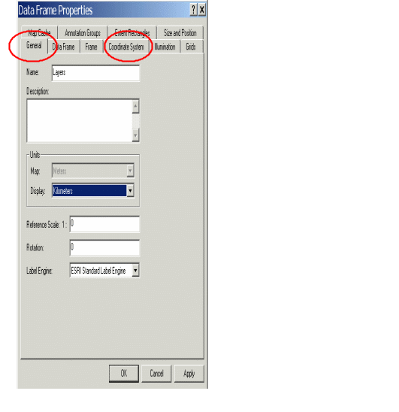

- From Insert→Scale Bar→Properties you can adjust the appearance of the scale bar, then click ‘OK’ to add it to view.

4.3 Adding map elements

Before you start adding elements to your map, ensure you activate the data frame for your map (by right clicking the data frame name and selecting ‘activate’). The data frame name will then be bolded.

- Go to Insert → North Arrow and you can select the style you want and click ‘OK’ to add it to the view.

- To add a legend for each data frame, go to Insert→Legend. Follow the legend wizard through, selecting the layers you want to include in the legend. Most of the default settings are fine. Click OK to add it to view, and drag it to the desired size and position. If you want to change or delete some of the text, right click the legend (it should be highlighted) and select ‘Convert to Graphics’. Right click again, and select ‘Ungroup’. This allows you to select each element of the legend separately, so you can change the legend name/font etc. If you double click text, a text box will open to modify it. When you are happy with the legend, you can select each of the elements in turn (hold down Ctrl while clicking) until all are selected and right-click →’Group’.

- Ensure your map has a title and the required text descriptions asked for.

- All of the data that goes into a map needs to be cited as the source. To add a text box with this information, go to Insert → Text. A text box will be added to the middle of the page by default. Add the text you want here (e.g. ‘Source: Leeds City Council, Census 2001 Key Statistics’) and adjust the font size using the toolbar at the bottom of the screen. When finished, you can move the text box to another part of the view. You can follow the same process to add a title.

Note, the UK borders website includes full details of how to reference their data (you don’t need to worry about this today, but you will need to think about this if you use any of these boundary data in your dissertation or a paper for publication). For example:

The boundary data used in this thesis are Crown Copyright produced by the Office for National Statistics (ONS). Licensed for academic use by the Economic and Social Research Council (ESRC) with the support of the Joint Information Systems Committee (JISC), which funded free access to the data for researchers in the UK. The data service providers are the Census Geography Data Unit (UK Boundary Outline and Reference Database for Education and Research Study: UKBORDERS) via Edinburgh University Data Library (EDINA). The 2001 Census Ward Boundaries are Crown copyright 2003 where Crown copyright material is reproduced with the permission of the Controller of HMS.

The Postcode Directories were also used in order to locate and convert postcode locations to Census geographies, such as super output areas. These directories provided by the Census Geography Data Unit (UK Boundary Outline and Reference Database for Education and Research Study: UKBORDERS) via Edinburgh University Data Library (EDINA). The directories’ copyright is © Crown Copyright 2006. Source: National Statistics / Ordnance Survey. Extracts are Crown Copyright and may only be reproduced by permission.

4.4 Saving and printing your map

You should save a copy of your ArcMap file – then these datasets will be available for you to use in the future (not so important in this workshop, but useful in ‘real life’!).

However you should also always save a copy of your final map into word or powerpoint (I prefer word). This ‘fixes’ your map precisely. Otherwise you can go back into ArcMap and find that the map has been changed or lost some functionality, and you will have to redo it. This is an endearing quirk of the ArcGIS software (not).

There are two opens for saving your final map (when you are happy with it):

Option 1
In Arc Map in layout view (view/layout view), click Edit, then click Copy Map to Clipboard
Open a new empty Word document
In the word document, choose edit, then “paste special” (if paste special isn’t there scroll down to find it). Do NOT use “paste”. Then choose “picture”.

Option 2
In ArcMap, go to File, then Export Map, and you can export the map as any one of several file types to be added in reports, powerpoint presentations, etc.

Always save the final version of your map in word or powerpoint when you are finished, and think of your ArcMap version as a working copy.

Suggested reading and references:
Cromley EK, McLafferty SL (2002). GIS and public health. Guilford publishers, London
Gatrell, AC (2002). Geographies of health: an introduction. Blackwell publishers, Oxford
Leyland AH & Davies CA (2005). Empirical Bayes methods for disease mapping. Statistical Methods in Medical Research, 14 (1): 17-34.
Monmonier M (1996). How to lie with maps. University of Chicago Press, London
Openshaw S (1983). The modifiable areal unit problem. Concepts and techniques in model geography. Environmental publications, Norwich
Rothman KJ and Greenland S (1998). Modern epidemiology. Second edition, Lippincott-Raven publishers, Philadelphia

Data Sources:
UK Borders: http://edina.ac.uk/ukborders/
UK Census: http://census.ac.uk/casweb/

Acknowledgements

Thanks to Dr Dianna Smith for collaboration with the initial workshop project for the Social Science and Medicine conference in September 2006, which we ran again at the ENRGHI conference in March 2007. This workbook was born out of those projects.

